**PURBANCHAL UNIVERSITY**

**ARYAN SCHOOL OF ENGINEERING  
AND MANAGEMENT**

Devkota Sadak, Mid- Baneshwor, Kathmandu, Nepal

**DEPARTMENT OF SCIENCE & TECHNOLOGY**



A PROJECT REPORT

ON

**‘’PHARMACY MANAGEMENT SYSTEM’’**

**SUBMITTED BY:**

RACHANA CHAUDHARY [311218]

SONAL KARN [311222]

TRIZA KARKI [311224]

**SUBMITTED TO:**

DEPARTMENT OF SCIENCE & TECHNOLOGY

**May 23, 2025**

# ACKNOWLEDGEMENT

We would like to express our heartfelt gratitude to my esteemed supervisors, **Er. Mukund Raj Joshi and Er. Sameer Kr** for their unwavering guidance, insightful feedback, and constant encouragement throughout the development of the Pharmacy System Management project. Their expertise and mentorship have been instrumental in shaping this work and enhancing my understanding of the subject. I am also deeply thankful to **Aryan School of Engineering and Management** for providing an exceptional academic environment, and the necessary resources that enabled us to successfully complete this project. The support from the faculty and the institution has been invaluable in achieving this milestone.

**Team members**:  
Rachana Chaudhary [311218]  
Sonal Karn [311222]  
Triza Karki [311224]

# ABSTRACT

This C-based Pharmacy Management System is a console application designed to manage users and medicine inventory through a role-based access system. It supports three types of users: Admin, and Staff, each with specific privileges. The program ensures secure registration and login using file-based credential storage, with separate files (admins.txt, and users.txt) for each user type. Password input is masked for privacy, and user inputs are validated to prevent errors.

Admins have the highest level of access, allowing them to monitor sales, view customer medicine records, manage the medicine inventory by adding, updating, or deleting medicine entries, view billing records, and register staff users. Staff members are provided with functionalities like searching medicines, generating bills, and maintaining billing.

One of the key features is the expiry management system, where the program reads medicine records from a file (medicine.dat), the staff compares the expired date based on the current date, and delete the expired medicine manually. Overall, the system uses structures for managing data, file operations for persistence, and standard C libraries for input/output. This project forms a strong foundation for a complete pharmacy system and can be extended with features like detailed billing, reporting, and GUI-based interfaces in the future.

**Key words:** *Pharmacy management system, Admin, Staff, Users, Medicine*

Table of Contents

ACKNOWLEDGEMENT i

ABSTRACT ii

LIST OF FIGURES iv

LIST OF TABLES v

Chapter 1. Introduction 1

1.1 Background 1

1.2 Problem Statements 1

1.3 Objectives 1

1.4 Applications 1

1.5 System requirement 2

Chapter 2: LITERATURE REVIEW 3

CHAPTER 3: METHODOLOGY 4

3.1 System Components 4

3.2Algorithm 5

3.3 Flowchart 7

3.4 Gantt Chart 10

CHAPTER 4: RESULTS AND DISCUSSIONS 11

Chapter 6: CONSLUCION 15

References 16

# LIST OF FIGURES

Figure 1: Flowchart (Part 1) 7

Figure 2: Flowchart (Part 2) 8

Figure 3: Flowchart (Part 3) 9

Figure 4:Gantt Chart 10

Figure 5: Login as Administrator 11

Figure 6: Administrator Panel 11

Figure 7: View Medicine 12

Figure 8: View Expired Medicine 12

Figure 9: Edit Medicine 12

Figure 10: Login as Staff 13

Figure 11: View the Medicine Expired Today 13

Figure 12: Generating Bills 13

Figure 13: Search Medicine 14

Figure 14: Exit Program 14

# LIST OF TABLES

Table 1: System Requirements 2

Table 2: User Roles and Permissions 4

## Chapter 1. INTRODUCTION

### 1.1 Background

Pharmacy management System is a software application designed to streamline and automate the workflow of a pharmacy. It helps to manage various operations such as inventory control, drug issuance, billing, and record keeping. This project, developed in the C programing language, demonstrates how basic data structures and file handling can be used to create a simple yet functional system for managing pharmacy operations. The program allows users to:

* Add and update medicine records
* Search medicines
* Manage sales and generate bills
* Maintain stock levels

By building this system in C, the project highlights fundamental programming concepts such as structures, arrays, and file operations. The primary goal of this project is to provide a lightweight and efficient solution for small-scale pharmacies

### 1.2 Problem Statements

The following issues highlight the need for an automated system:

* **Inventory Inaccuracies**: Manual tracking often results in stock outs or overstocking, affecting operational efficiency and costs.
* **Security Risks**: Lack of role-based access control increases the risk of unauthorized data access, compromising sensitive information.
* **Inefficient Billing**: Manual billing processes are time-consuming and susceptible to errors, delaying customer service.
* **Expiry Date Oversight**: Failure to monitor medicine expiry dates can lead to dispensing expired medications, posing health risks.
* **Poor Customer Record Management**: Disorganized records hinder personalized customer service and loyalty programs.

### 1.3 Objectives

To build pharmacy management system using C programming.

### 1.4 Applications

Applications of a pharmacy management system:

* **Retail Pharmacies**: For managing daily operations and customer interactions.
* **Hospital Pharmacies**: To support large-scale medicine dispensing and inventory control.
* **Clinic Dispensaries**: For small-scale medication management.

### 1.5 System requirement

*Table: System Requirements*

|  |  |
| --- | --- |
| **Requirement Type** | **Details** |
| Hardware | Personal Computer with ≥2GB RAM, 100GB HDD |
| Software | Windows OS, C compiler, Database (e.g., MySQL) |

Table 1: System Requirements

# Chapter 2: LITERATURE REVIEW

The development of automated pharmacy management systems has been a focal point in recent healthcare technology research, driven by the need to reduce human error and improve operational efficiency conducted an in-depth study on role-based access control in healthcare inventory systems, demonstrating that implementing tiered access levels significantly enhances security and accountability. [1] Their findings indicate that systems with distinct user roles can prevent unauthorized access to sensitive operations, a principle directly applied in this PMS through its super admin, admin, and staff roles. Kumar and Patel explored the importance of date validation in pharmaceutical management, emphasizing that accurate expiry date tracking is critical to patient safety. [2] They found that systems lacking robust date validation often lead to the dispensing of expired medicines, a risk this PMS mitigates through its validate Date () function, which enforces the YYYY-MM-DD format and validates date ranges. Lee [3] provided a comparative analysis of programming languages for healthcare applications, highlighting C’s advantages in performance-critical systems due to its low-level control and minimal resource overhead. This supports the choice of C for this project, as pharmacies often operate on legacy hardware where efficiency is paramount. Gupta investigated file-based storage solutions for small-scale healthcare applications, concluding that text files offer a simple, cost-effective method for data persistence in environments lacking database infrastructure. This aligns with the PMS’s use of text files (medicine.txt, superadmins.txt) for storing inventory and user data, ensuring accessibility without requiring advanced database management skills. Finally, Zhang and Chen examined user interface design in command-line interface (CLI) systems, particularly in healthcare contexts, and found that intuitive navigation and clear prompts significantly improve user adoption rates. Their insights influenced the design of this system’s menu-driven interface, which prioritizes simplicity and clarity to accommodate users with varying technical expertise. Collectively, these studies provide a strong foundation for the proposed PMS, addressing gaps in security, data accuracy, and user experience identified in prior research. [3]

# CHAPTER 3: METHODOLOGY

The Pharmacy Management System was developed using the C programming language, selected for its efficiency and portability. The system employs a modular architecture, with distinct components for user management, medicine management, billing, and reporting, all utilizing file-based storage for data persistence.

## 3.1 System Components

* **User Management**: Stores credentials in files (“admins.txt”, “users.txt”) with roles (admin, staff). Functions include registration, login, and role-based access control, ensuring only authorized actions are performed.
* **Medicine Management**: Maintains medicine records in “medicine.dat”, including ID, name, company name, price, expiry date, and quantity. Functions support adding, updating, deleting, and searching medicines, with validation for expiry dates.
* **Billing and Sales**: Generates bills for sales, updates medicine quantities, and records transactions.
* **Reporting**: expired medicine generates sales reports, aiding decision-making.
* **User Interface**: Utilizes console-based input/output, suitable for environments without graphical interfaces, with beep alerts for invalid input.
* **Error Handling**: Validates inputs, date formats, and file operations to maintain data integrity.

|  |  |
| --- | --- |
| **Role** | **Permissions** |
| Admin | Add Medicine, Update Medicine, Delete Medicine, View sales record, Register Staff, View expired medicine |
| Staff | Search Medicine, Generate Billing, Keep Record of Bills, View expired medicine |

Table 2: User Roles and Permissions

## 3.2Algorithm

Step 1: Start

Step 2: int choice

Step 3: Display login panel

Admin

Staff

Exit

Step 4: if choice =1 then,

Display admin login panel

register

login

exit

Step 4. 1: if choice is 1 then, enter username and password

Step 4.2: if choice is 2 then, enter username and password

Step 4.3: if entered user name and password is equal to registered user name

Password display login successful

Step 4.4: if login successful display admin panel

Register staff

Add medicine

Delete medicine

Update medicine

Delete medicine

View medicine

View sales

View expired medicine

Log out

Step 4.6: if choice =1 then, enter username and password for the staff

Step 4.7: if choice =2 then, enter id, name, company name, price, expired date, quantity of the medicine

Step 4.8: if choice=3 then, enter id of the medicine and delete the medicine details

Step 4.9: if choice=4 then, update medicine details

Step 4.10: if choice =5 then, enter id of the medicine and delete the medicine details

Step 4.11: if choice=6 then, display the details of medicine

Step 4.8: if choice = 7 then, display the name and company name of expired medicine which is expired today

Step 4.9: goto login panel

Step 5: if choice =2 then, enter the username and password

Step5.1: if the entered user name and password and the user’s name and password enter by admin is equal the display login successful

Step 5.2: if login in successful the display staff panel

View medicine

Search medicine

Generate bills

Log out

Step5.3: if choice=1 then, display all the details of medicine

Step5.4: if choice =2 then, search the medicine through name the details of medicine is displayed and also display if it’s available or not

Step5.6: if choice=3 then, the staff generates the bill containing the SN, name of medicine, quantity, price, total price of medicine

Step5.7: display would you like to buy more medicine yes, or no?

Step 5.8: if yes then goto step 5.4 else go to staff panel

Step 5.9: if choice=4 then, return to login panel

Step 6: if choice=3 the display Thank you!!Have a nice day!!!

Step 7: Stop

## 3.3 Flowchart

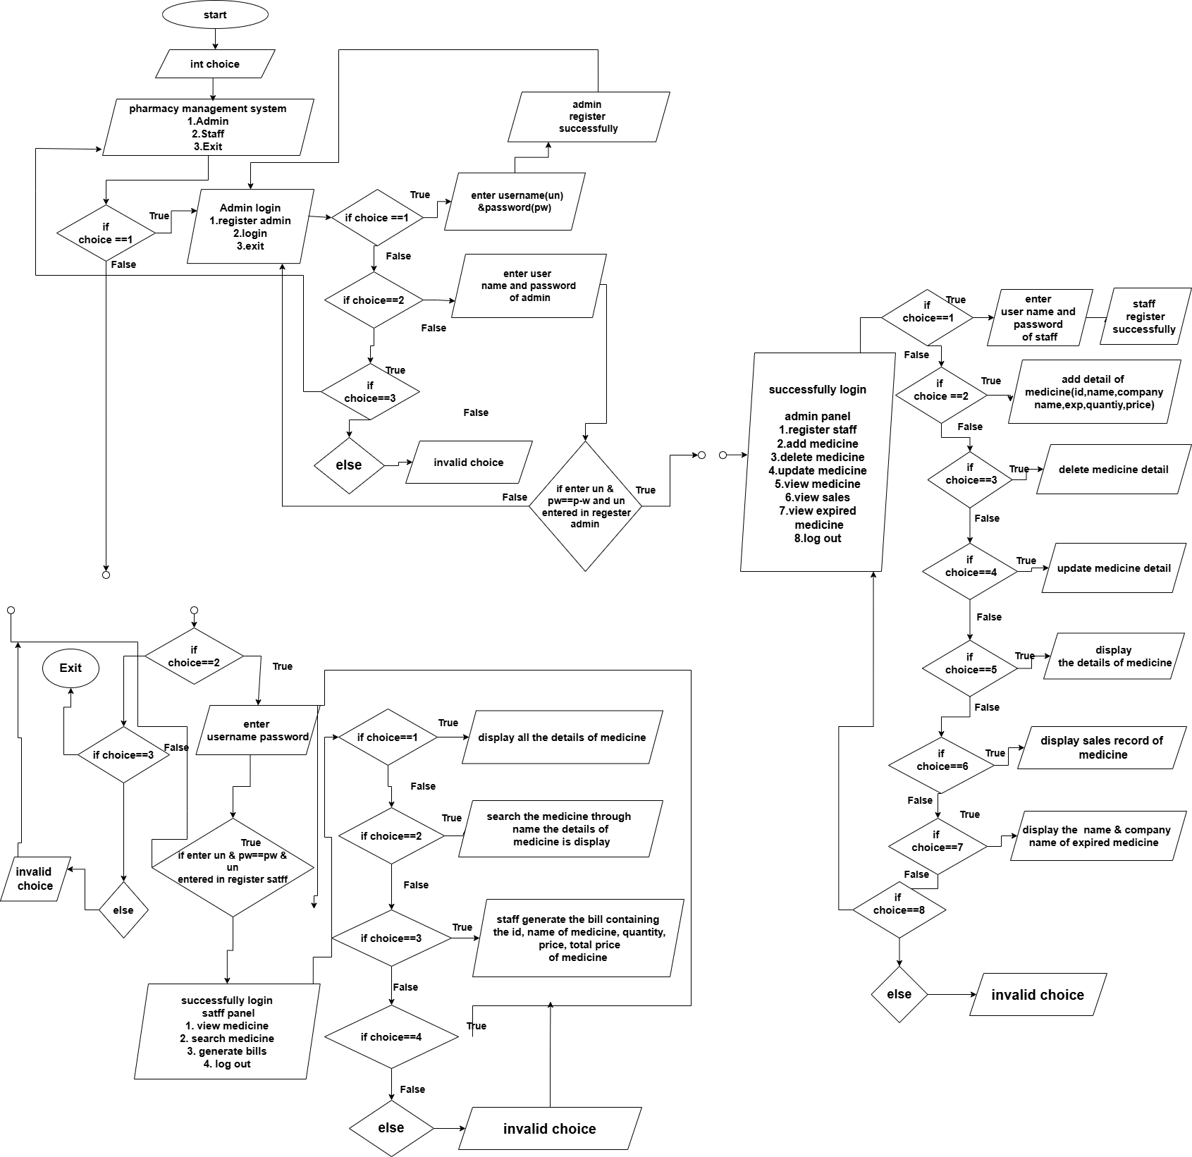

Figure 1: Flowchart (Part 1)

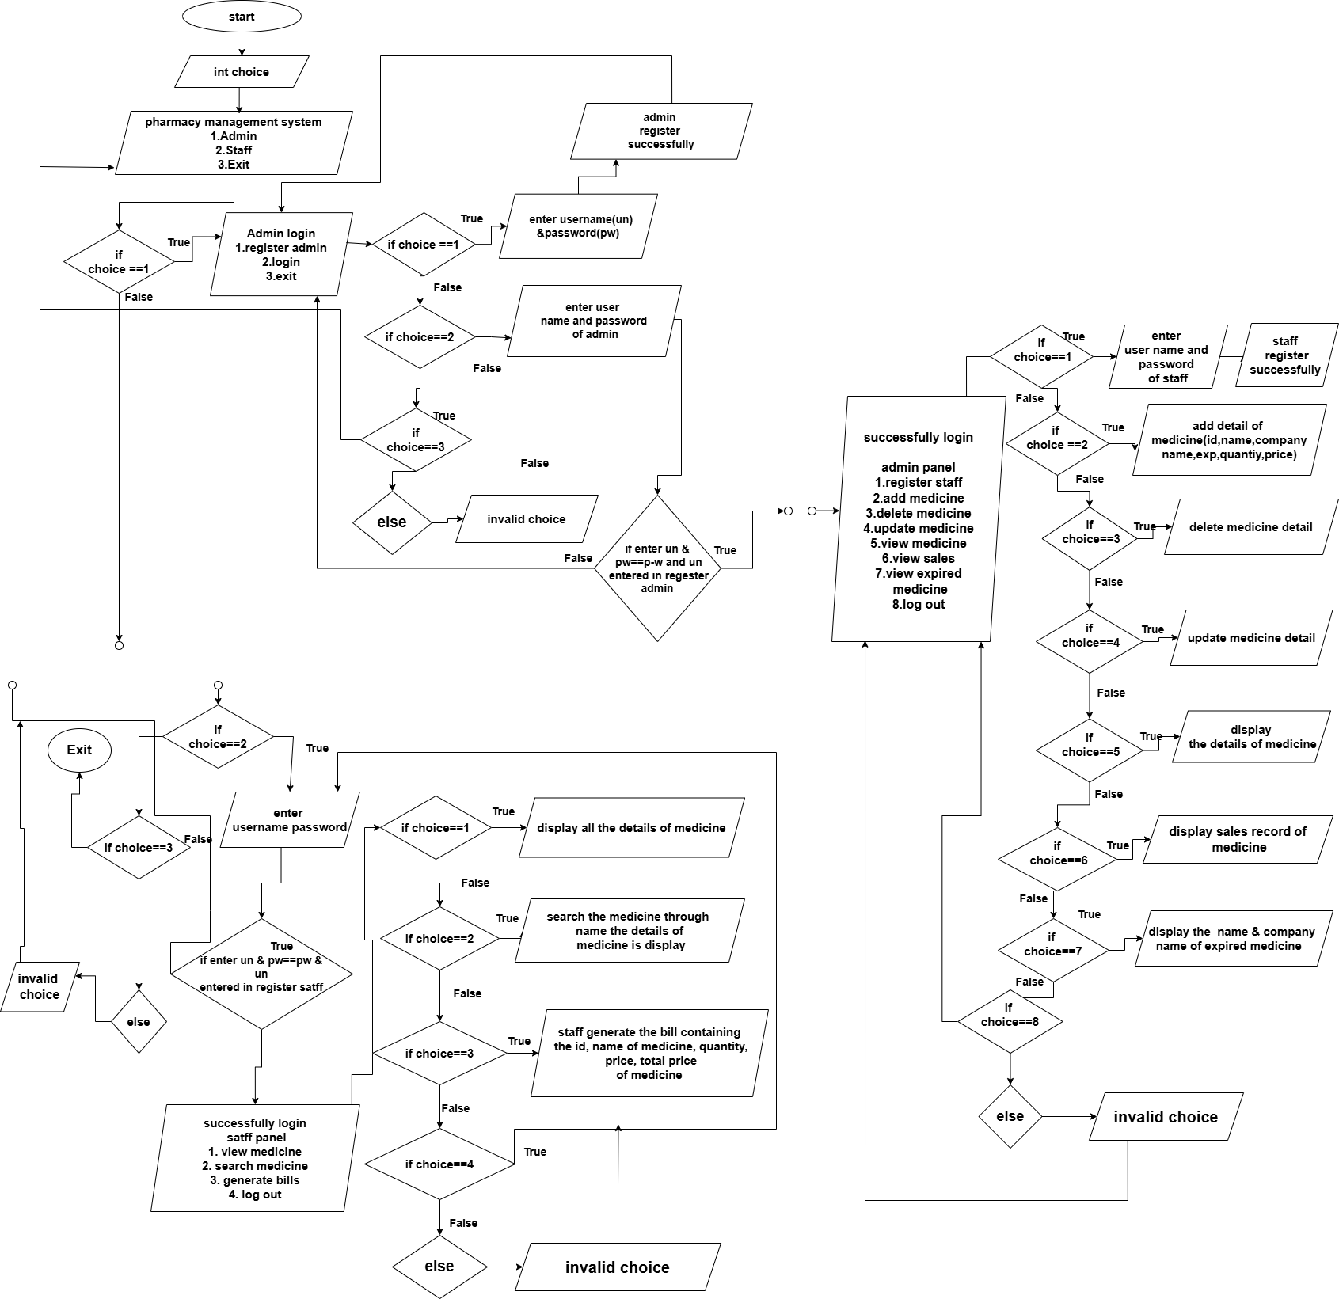

Figure 2: Flowchart (Part 2)

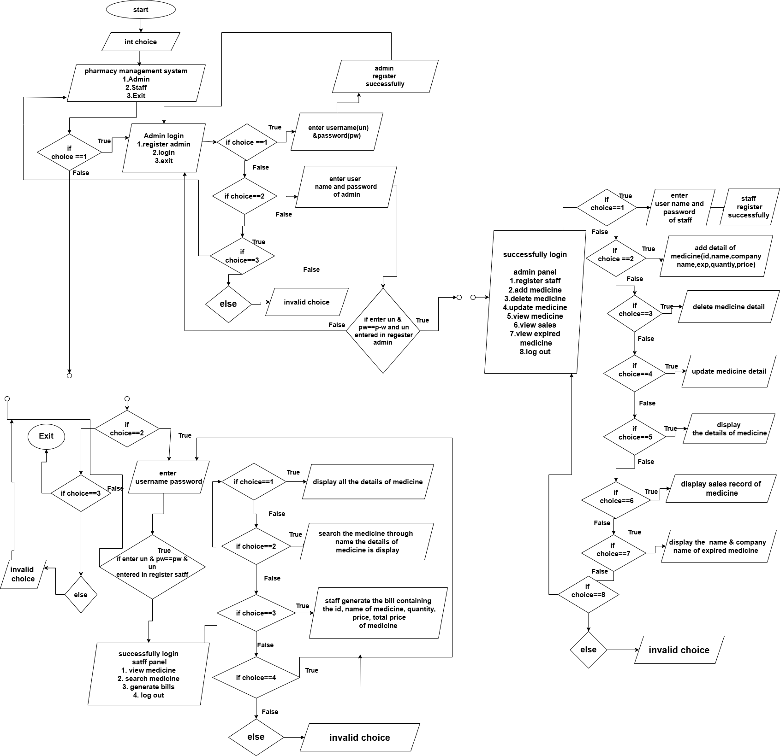

Figure 3: Flowchart (Part 3)

## 3.4 Gantt Chart

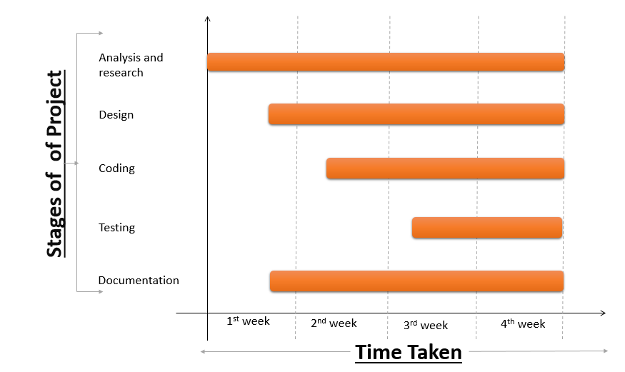

Figure 4:Gantt Chart

# CHAPTER 4: RESULTS AND DISCUSSIONS

The Pharmacy Management System, built in C, successfully manages medicine inventory, user authentication, and billing. Admins can register, add/edit medicines (e.g., ID: 101, Name: Paracetamol, Price: $50, Expiry: 2025-06-01), and view expired medicines (e.g., before May 22, 2025). Staff can generate bills (e.g., 10 units of ID 101, Total: $500) and edit expiry dates for medicines expiring today. Data is stored in text files (medicine.txt, bills.txt).

We have done the coding. And our output of the coding is displayed below:

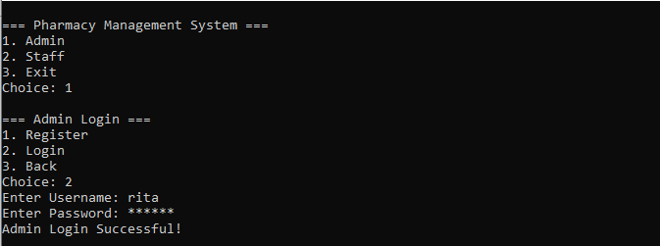

Figure 5: Login as Administrator

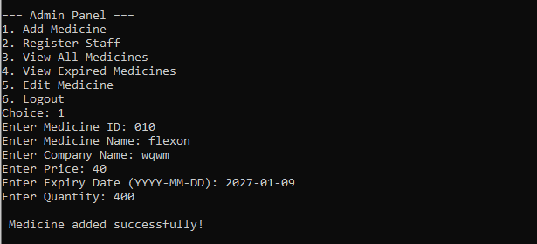

Figure 6: Administrator Panel

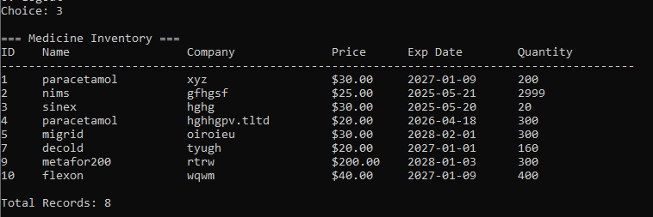

Figure 7: View Medicine

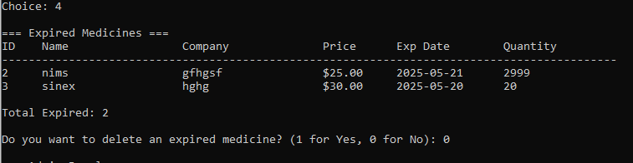

Figure 8: View Expired Medicine

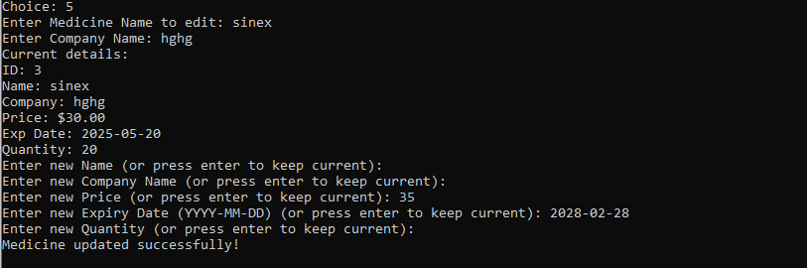

Figure 9: Edit Medicine

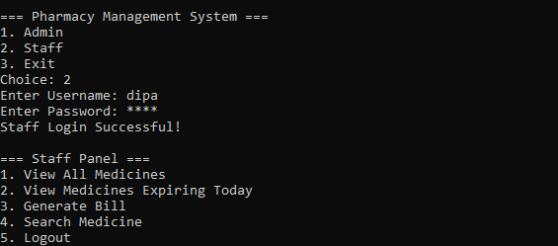

Figure 10: Login as Staff

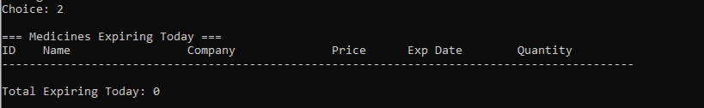

Figure 11: View the Medicine Expired Today

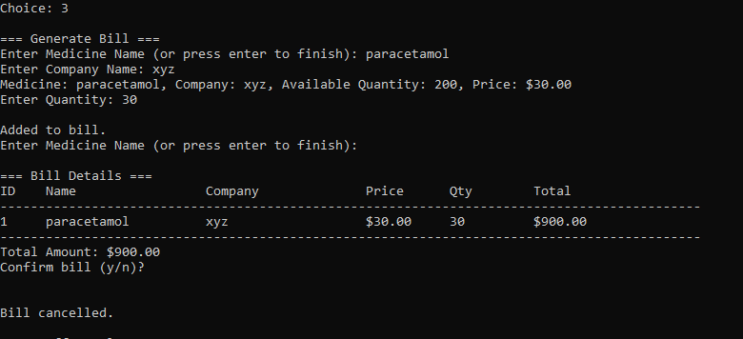

Figure 12: Generating Bills

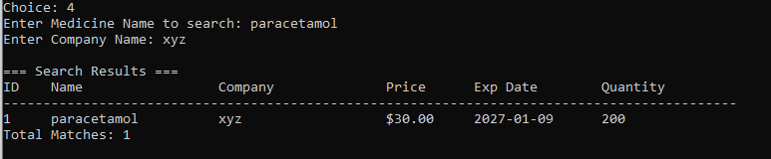

Figure 13: Search Medicine

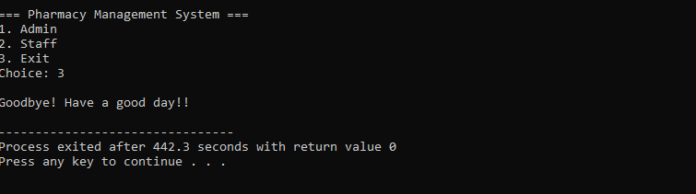

Figure 14: Exit Program

# Chapter 6: CONSLUCION

This program is an efficient Pharmacy Management System that provides separate panels for administrators and staff. Administrators can add, edit, and view expired medicines, as well as register new users. Staff members can view the medicine inventory, identify medicines expiring today, edit expiry dates, and generate bills. The system stores data in files, organizing entry, editing, and billing processes effectively. Features like date validation, user authentication, and error notifications with a user-friendly interface make it practical. It is suitable for small-scale pharmacy management and can be scaled up with further enhancements.

# References

|  |  |
| --- | --- |
| [1] | N. L. o. Medicine, "National Library of Medicine," 19 Feburary 2018. [Online]. Available: https://pmc.ncbi.nlm.nih.gov/articles/PMC5836325/. [Accessed 2 June 2025]. |
| [2] | patheon.com, "Pharmaceutical Manufacturing Solutions," 2 June 2025. [Online]. Available: https://www.patheon.com/us/en/innovative-solutions/manufacturing.html. |
| [3] | W. H. Organization, "World Health Organization," 2 June 2025. [Online]. |